

EE5103 Computer control Part II CA

A0260014Y

Guo Shiping

Contents

Part 1 1

Part2 5

Part 3 12

Conclusion 20

# **Part 1**

Model is given:

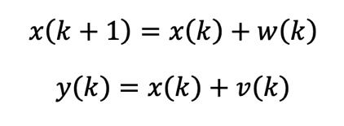

Where $w(k)$ and $v(k)$ are zero-mean independent Gaussian random variables with standard deviations $σ_{w}= 0.1$ and $σ_{v}= 1$ respectively. The initial condition $x(0)= 5$. First set the initial covariance of state $P(0|-1)=100000$.

$$k= 0, 1, ..., N where N = 10000$$

Use $K_{f}$ matrix store Kalman Gain value, x matrix stores values $P(k+1|k)$*.*

The initialization of $P_{m}$ is set to 10000, $P_{m}(:,1)=100000$. Use equations

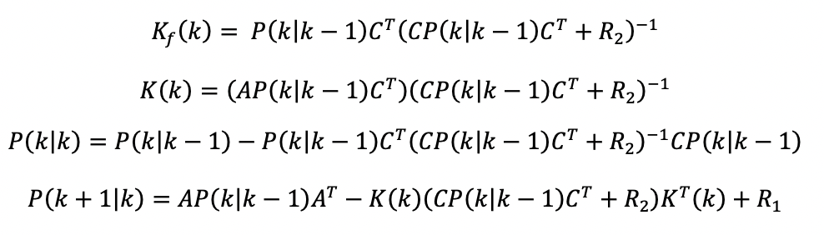

To calculate Kalman Gain and update the estimate uncertainty and extrapolate uncertainty.

Then use equations:

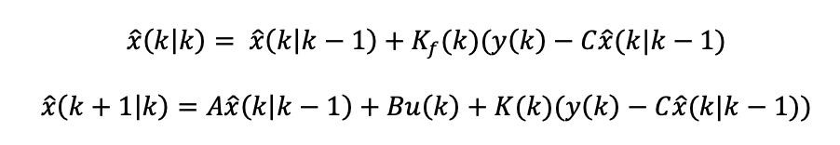

To update estimate with measurement and extrapolate the state.

We already know the variance and mean of the noise, we can use Matlab function random to generate the noise.

The simulation results are following:

**Graph 1**



Figure 1 The overall figure

Graph 1 The overall figure



Graph 1 The zoom in figure

**Graph 2**



Graph 2 Overall figure



Graph 2 Zoom in figure

**Graph 3**



Graph 3 Overall figure



Graph 3 Zoom in figure

**The bias and variance**

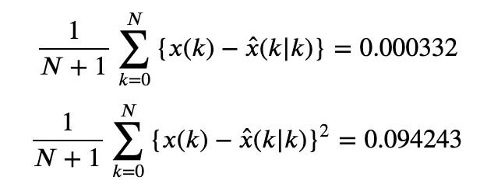

# **Part2**

Model is given:

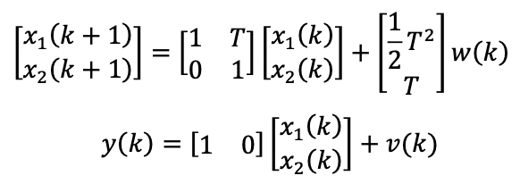

Where $w(k)$ and $v(k)$ are zero-mean independent Gaussian random variables with standard deviations $σ_{w}= 0.1$ and $σ_{v}= 1$ respectively. The sampling period is $T = 1$. The initial conditions are $x_{1}= 0$ and $x_{2}= 30$.

Use the same Kalman filter estimation equations mentioned in Part I to calculate the Kalman gain and estimation uncertainty.

Then use the following equations to calculate the true states and estimated states.

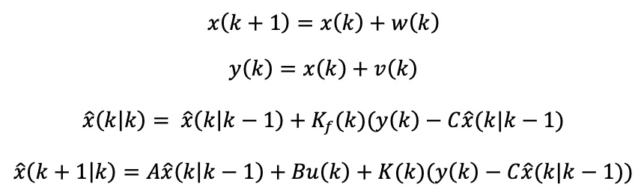

The following graphs are the simulation results:

**Graph 4**



Graph 4 Overall figure



Graph 4 Zoom in figure

**Comment**

Since the process uncertainty is very low so the result should follow process result and doesn’t be affected by measurement too much. The result also prove this. The predicted outcome closely aligns with the actual result, signifying a high level of accuracy in the prediction.

**Graph 5**



Graph 5 Overall figure



Graph 5 Zoom in figure

**Graph 6**



Graph 6 Overall figure



Graph 6 Zoom in figure

**Graph 7**



Graph 7 Overall figure



Graph 7 Zoom in figure

**Graph 8**



Graph 8 Kf1 Overall figure



Graph 8 Kf1 Zoom in figure

**Graph 9**



Graph 9 Kf2 Overall figure



Graph 9 Kf2 Zoom in figure

**The bias and variance**

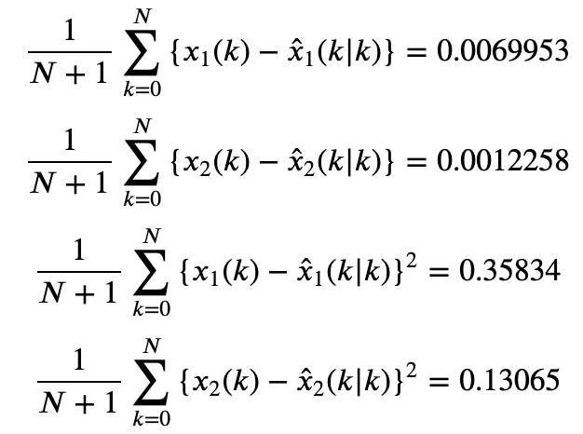

# **Part 3**

For part 3, we can do the simulation under two situations.

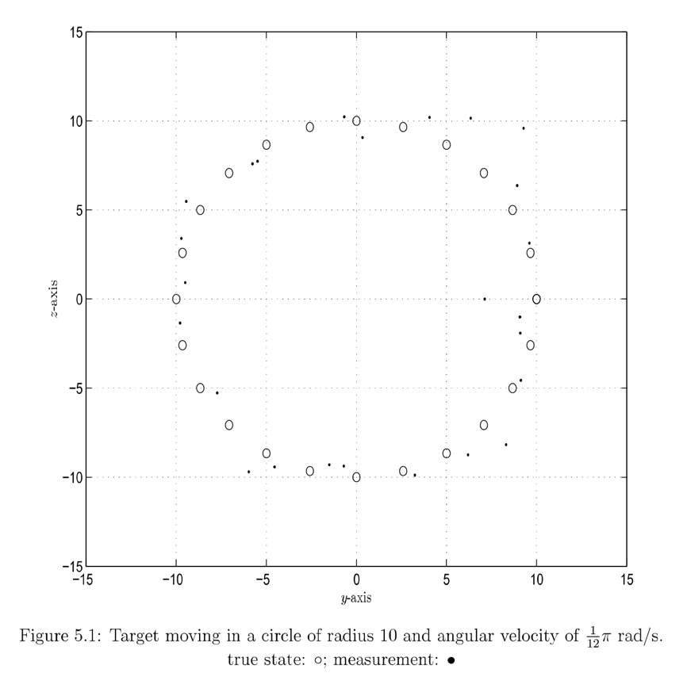

**Part 3-1**

First, the question already shows the target move in a circle.

So, we can build a model based on the moving trajectory.

The motion model is:

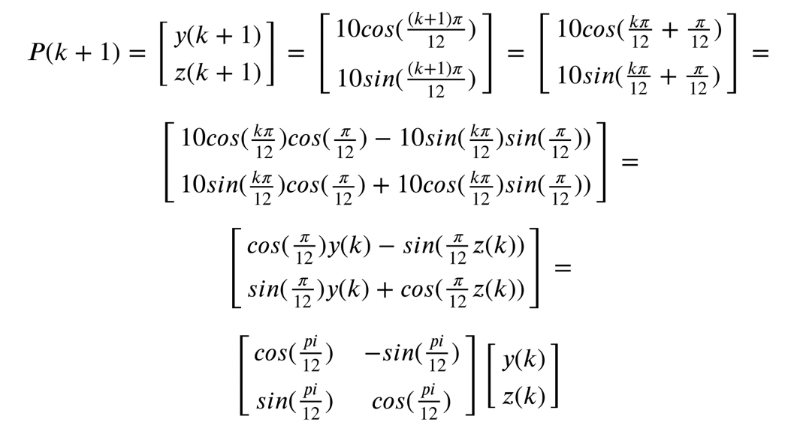

So the state space model is:

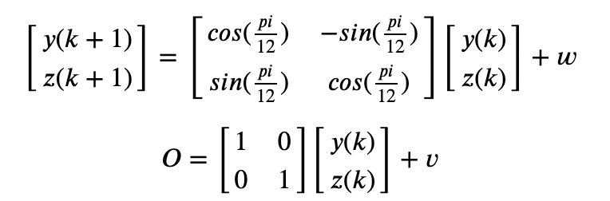

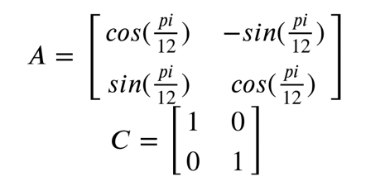

Suppose the motion model also has noise with variance 1. So $R_{1}=\left[\begin{matrix}1 & 0 \\ 0 & 1\end{matrix}\right]$. The measurements noise $R_{2}=\left[\begin{matrix}1 & 0 \\ 0 & 1\end{matrix}\right]$. The initial state are quite uncertain, $y\left(k\right)$ and $z\left(k\right)$ are independent, $cov\left(y,z\right)=0$ and $cov\left(z, y\right)=0$, set initial covariabce of states $P\left(0 | 1\right)=\left[\begin{matrix}10000 & 0 \\ 0 & 10000\end{matrix}\right]$.

Use the model mentioned above the Kalman equations are:

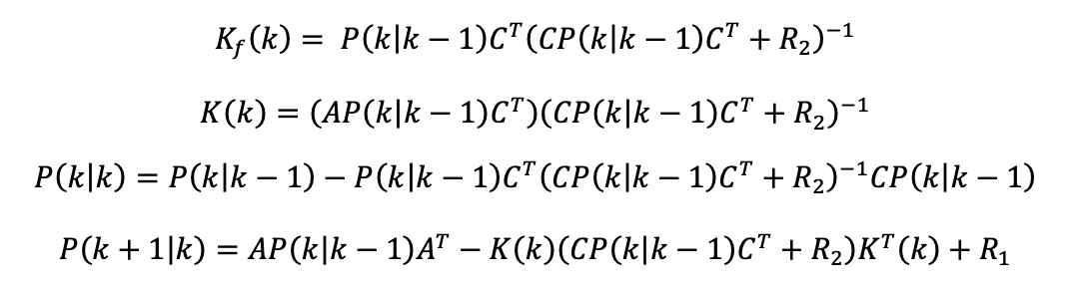



Graph 10 Circle movement KF estimation result



Graph 11 Circle movement KF Kf



Graph 12 Circle movement KF K



Graph 13 Circle movement KF P



Graph 14 Circle movement KF Pm

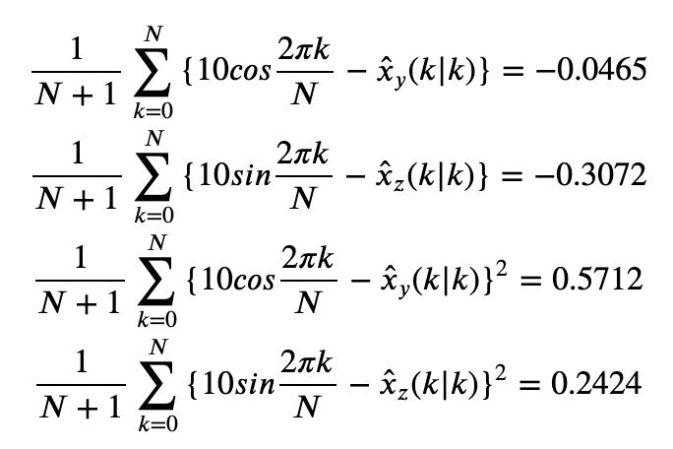

**Part 3-2**

Second, in most condition we don’t know the trajectory model and can only depend on the measurement. Use the normal motion formula we can design another state space model.

The motion equation is:

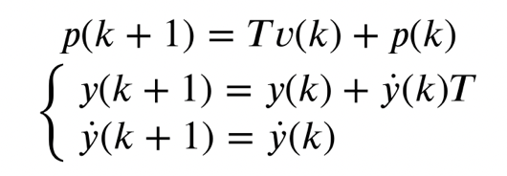

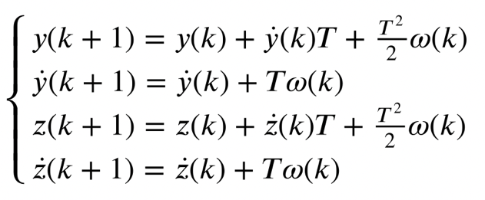

So the state space model is:

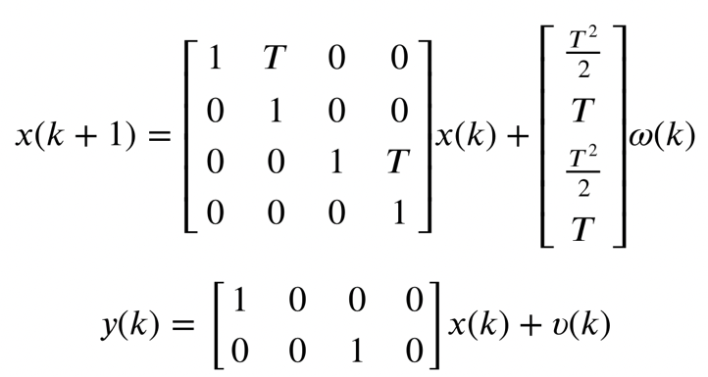

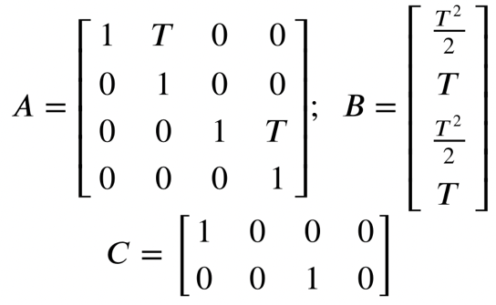

The noise matrix can be written as:

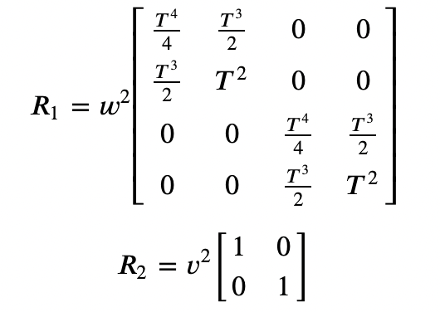

Use the same Kalman equations mentioned above.

The final result is:



Graph 15 Normal movement KF estimation result



Graph 16 Normal movement KF Kf



Graph 17 Normal movement KF K



Graph 15 Normal movement KF P



Graph 15 Normal movement KF Pm

**Bias and variance**

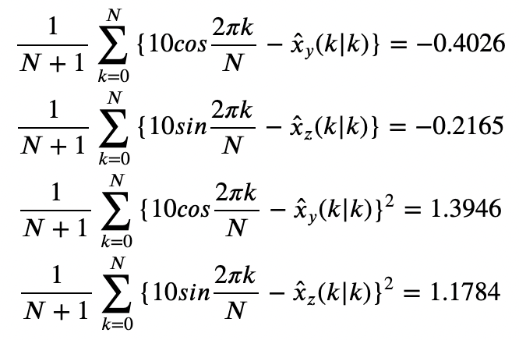

**Comments and thinking**

1. When contrasting these two methods, it becomes evident that the motion model holds significant importance. It becomes apparent that having prior knowledge of the motion model and designing a precise one can lead to improved performance, even when the level of motion process noise remains consistent.

Here I also encountered some problems and questions.

For example, during estimation iteration should I directly use the measurement number or add noise on them?

Upon reviewing the derivative of the entire Kalman Filter process in the lecture notes, I think that the noise is introduced to the states when do the measurement, not to the measurements themselves. In this context, it's important to recognize that we possess knowledge of the measurements. Consequently, adding noise directly to the measurements would be redundant, as the given measurements inherently encompass noise.

2. Setting R2 to all zeros leads to the estimated results aligning closely with the measurements, which is expected and reasonable. However, an interesting observation emerges when R1, the noise matrix, is also configured with all zeros. In intuition, this setting should cause the estimated results to strictly adhere to the motion process model. Surprisingly, in practice, the results do not perfectly follow the motion model; they are influenced by the measurements. This indicates that the measurements have a discernible impact on the estimation process, even when R1 is zero.

Indeed, when R2 is set to zero, the estimated results will precisely track the measurements, aligning with expectations.

Conversely, when R1 is configured as zero, the estimation results do not entirely conform to the process model as initially anticipated. Upon reviewing example 3 in the lecture notes, it becomes evident that in this scenario, the estimation results take the form of a least-squares process estimate or, in cases where all coefficients are equal, an average of the measurements. This highlights the influence of the measurements, even when R1 is reduced to zeros.

# **Conclusion**

In all three segments, Kalman Filter is employed to estimate the system states by utilizing both groundtruth values and measurements. In the first two segments, we are provided with the uncertainties of 𝑅! and 𝑅", and we employ the Kalman Filter algorithm's equation set to iteratively update all variables within the algorithm for state estimation.

In the third segment, I build two different models under two situations. The final result shows the importance of right processing model. Besides, the final trajectory of estimated states validates this decision, as the measurements exhibit significant noise, while the model remains accurate, leading to a convergence of the estimated states towards the ground truth values.

Notes: Most of the equations are edited in Jupyter Notebook by using Latex form. I use screenshot to show them in the words file which may cause the different size. Hope to be understood.